UTx000 Device Return Instructions

This document guides participants in the summer 2020 UTx000 study through the process of returning their Fitbit and/or Beacon devices to the study coordinators.

# Packing up the Devices

TLDR: Don’t like reading? Watch the video on packing up the devices [here](https://youtu.be/m_7nJ7iGOYc) instead.

## Open the Return Box

A box with approximate dimensions of 6”x6”x12” should have been sent to you. Open the box carefully along the taped edge and remove the materials inside. You should have received:

* 5 blank adhesive shipping labels
* A 4’ roll of 12” wide bubble wrap

## Fitbit

1. Start by locating the original box the Fitbit arrived in

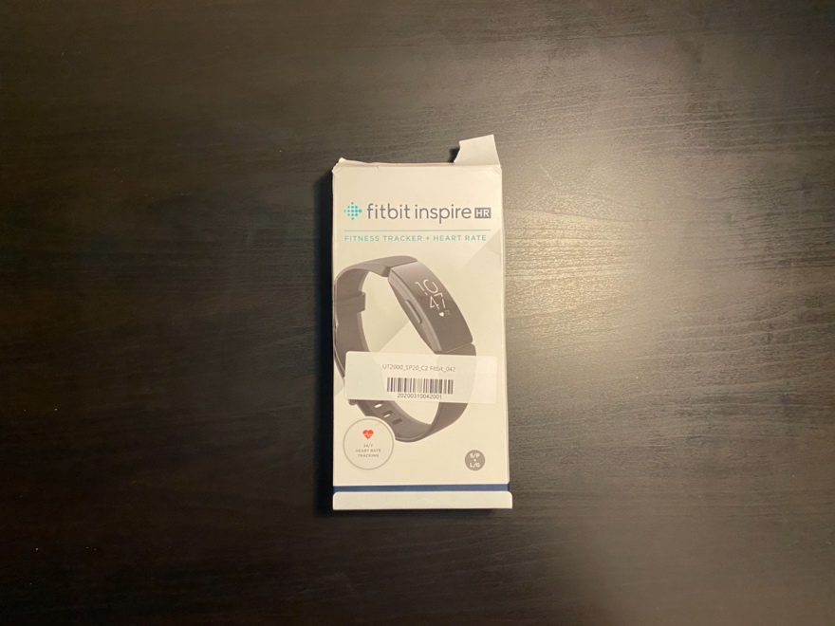

1. Gather your Fitbit and all accompanying accessories: the charger and extra wrist strap

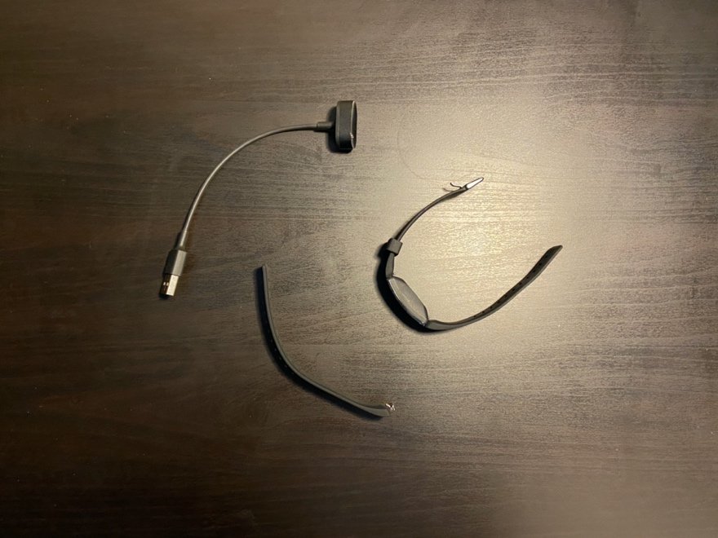

1. Remove the insert from the box by opening the bottom of the box to reveal a pull-tab

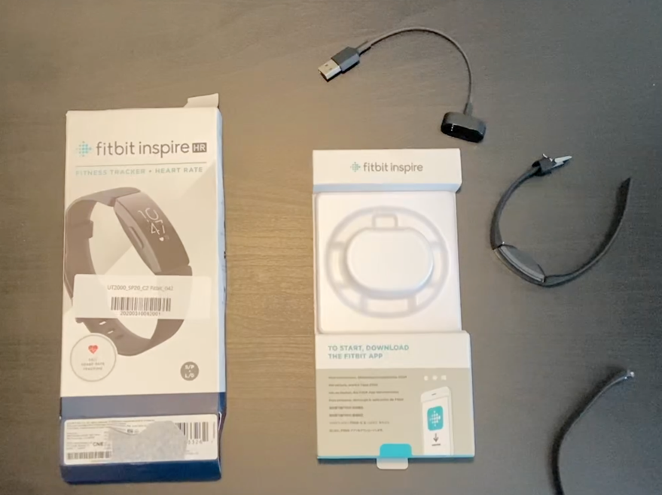

1. Cinch the Fitbit strap to a large setting and place around the plastic indent on the insert

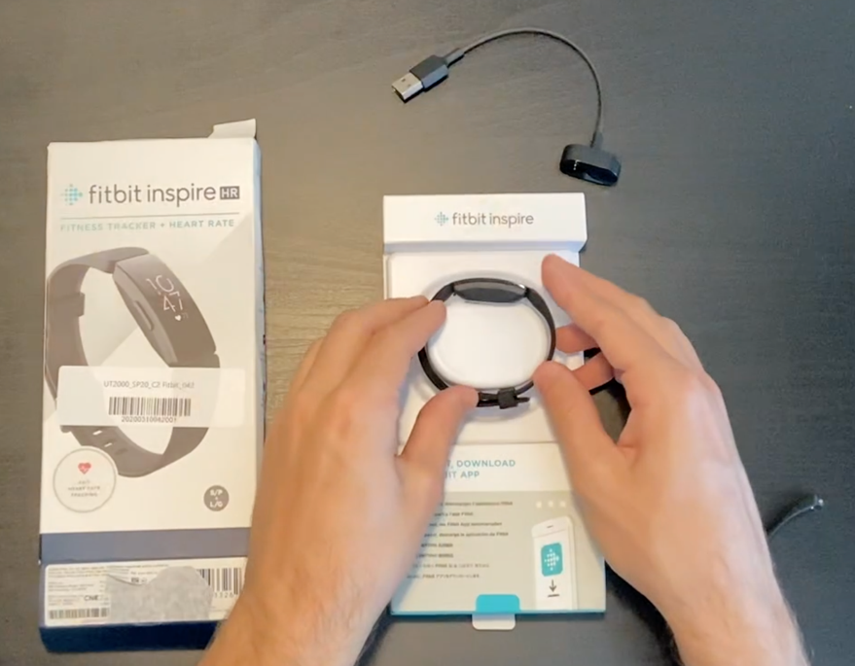

1. Open the small compartment on the insert and place the wrist strap and charger inside. Seal up the compartment afterwards.

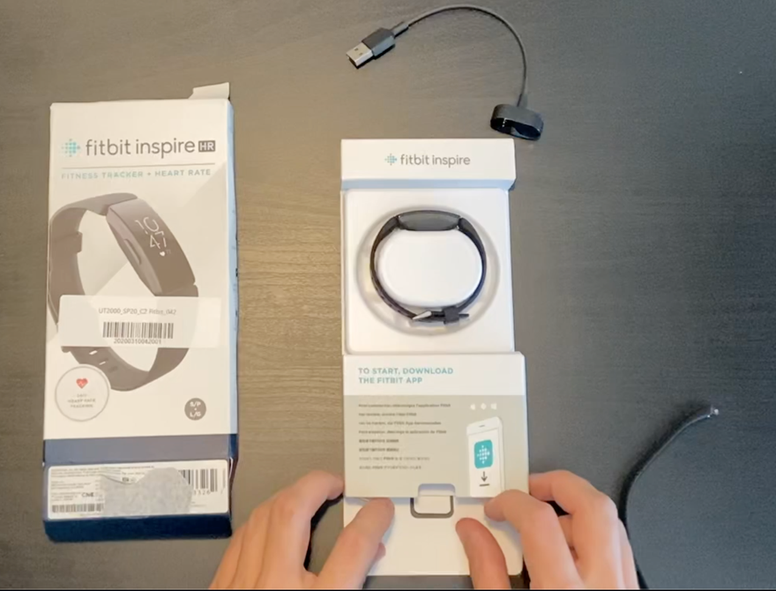

1. Slide the insert back into the Fitbit box and close the box up

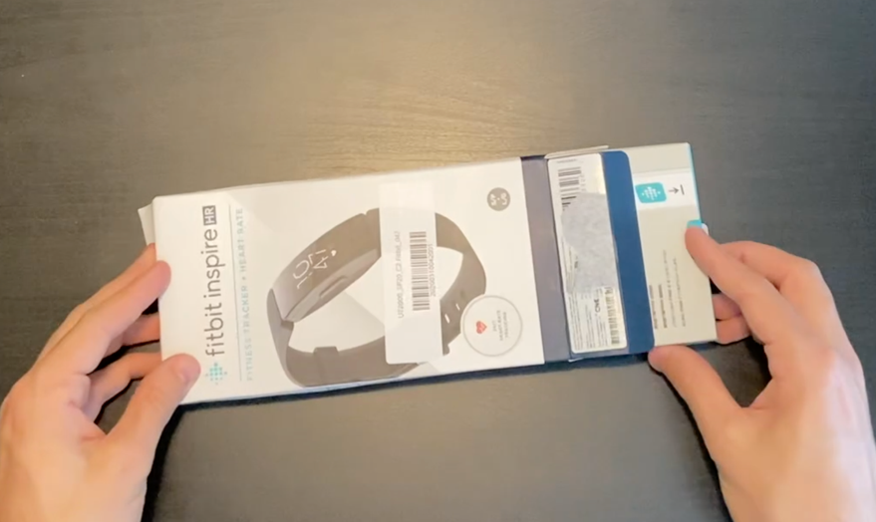

1. Take a blank adhesive shipping label and use it to secure the box

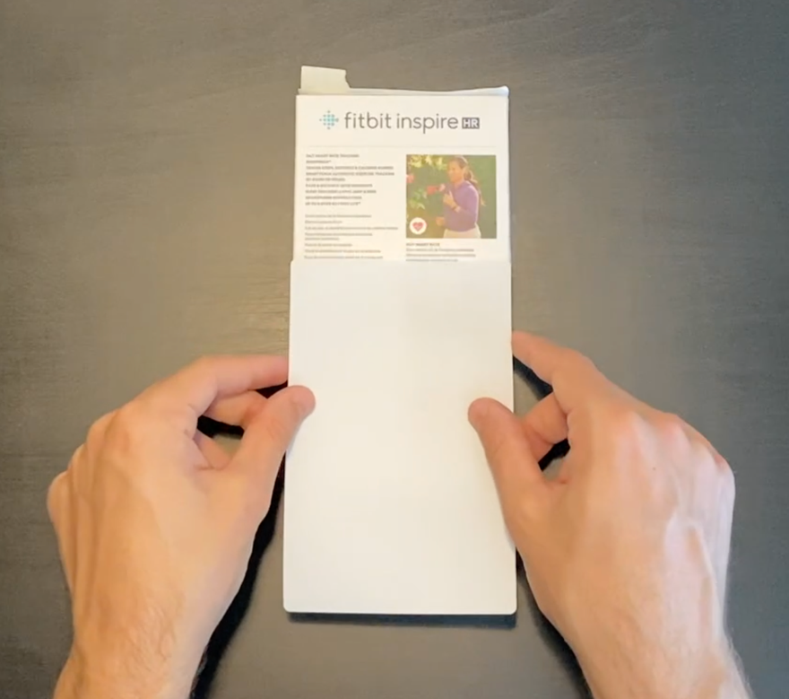

## Beacon

1. Unplug your beacon and remove the cord from the device

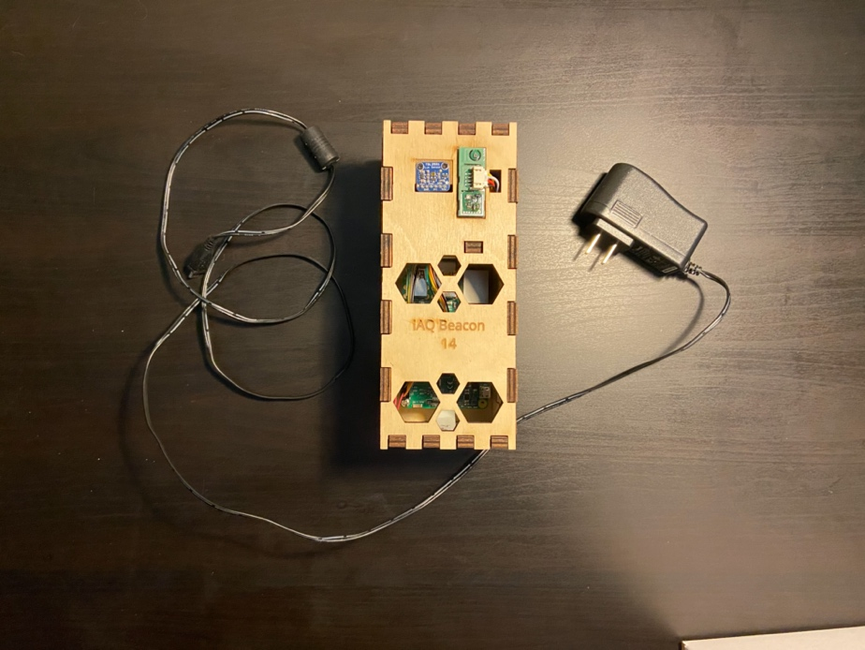

1. Locate a flat surface and unravel the bubble wrap

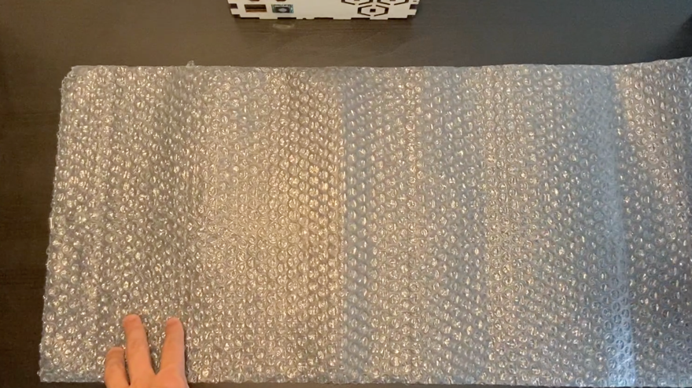

1. Place the beacon lengthwise a few inches from the edge of the bubble wrap

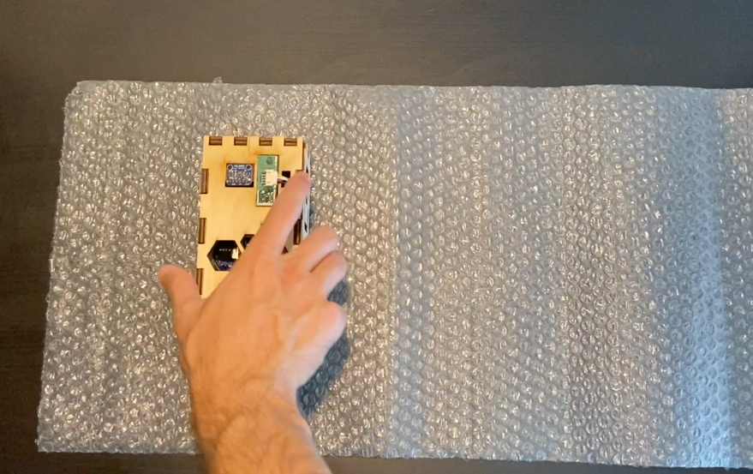

1. Carefully begin to wrap the beacon in the bubble wrap until only a small portion of the bubble wrap remains

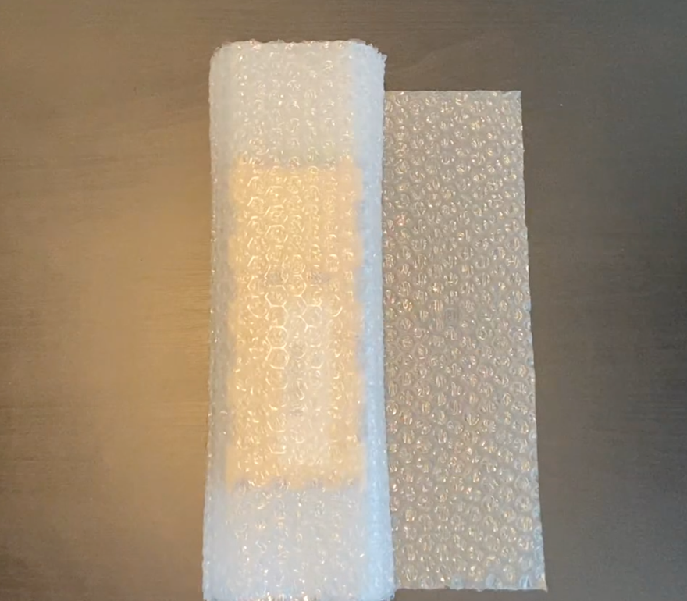

1. Using another blank adhesive shipping label, secure the loose end of the bubble wrap around the device

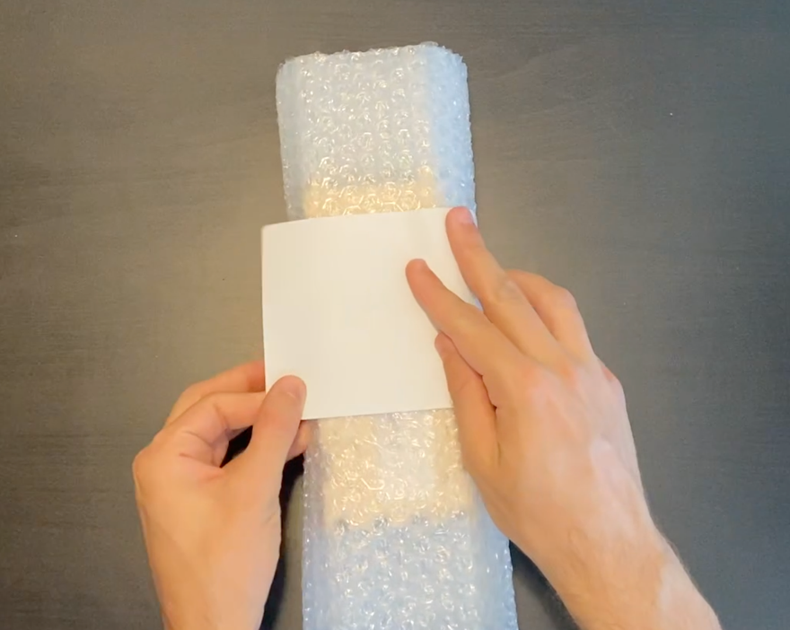

## Packing the Return Box

1. Place the beacon in the bubble wrap lengthwise in the box – the device should fit snugly

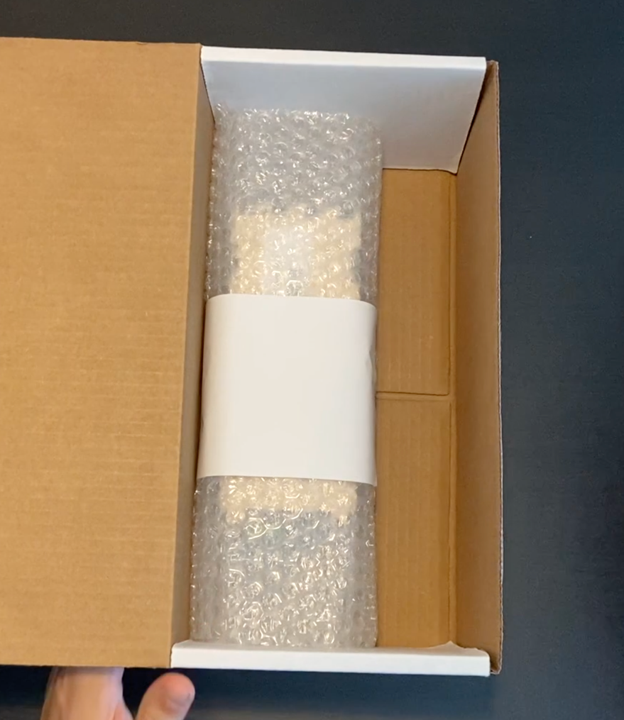

1. Rotate the Fitbit box to the skinny side and slide into the available space

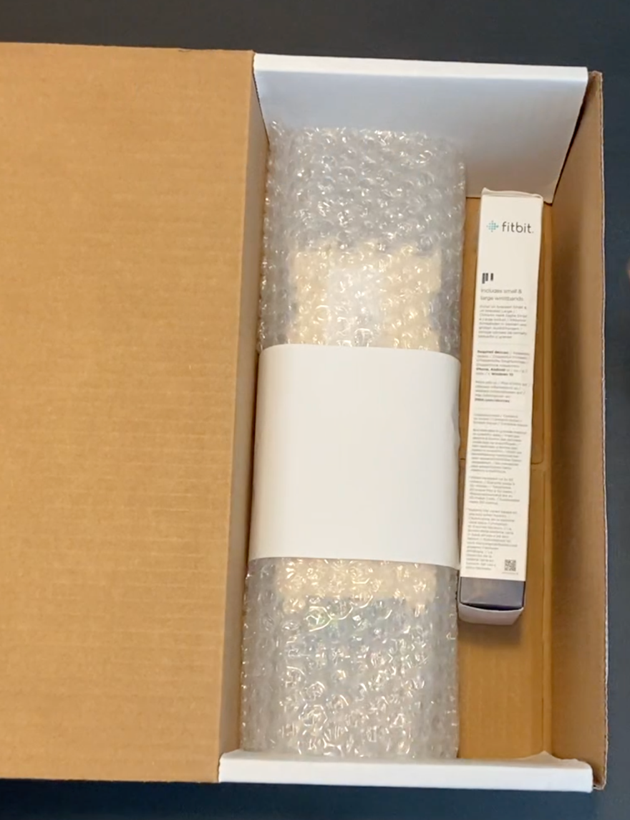

1. Take the beacon power cable, coil it as best as you can, and place it in into the box wherever there is available space

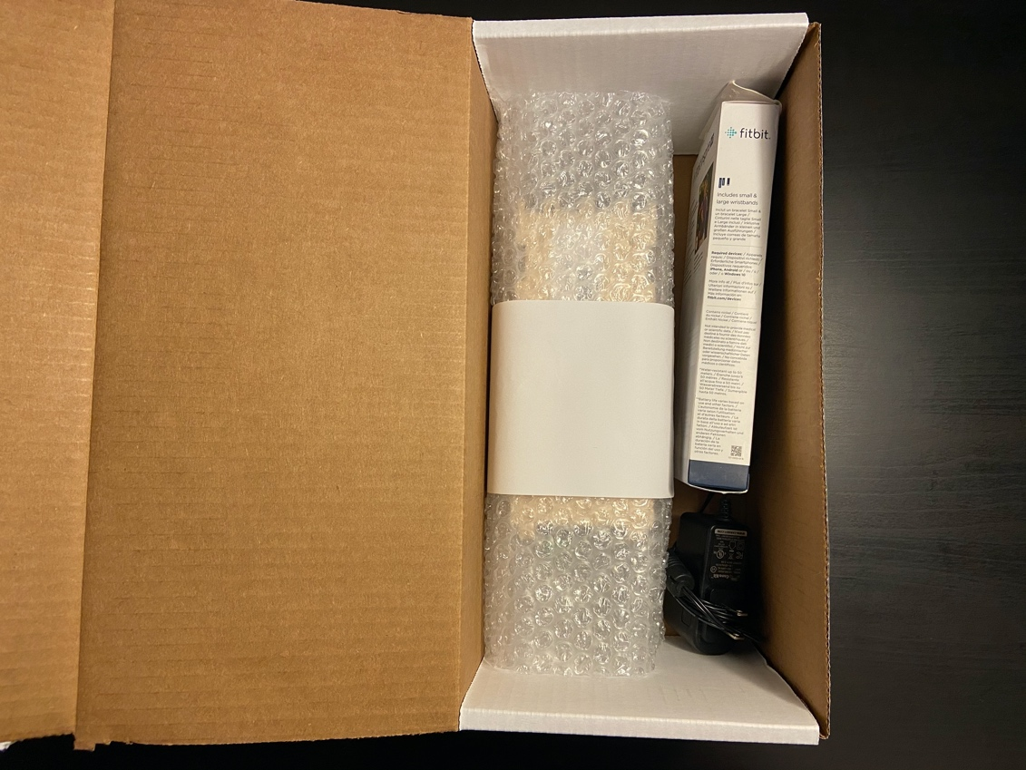

1. Identify the two shipping labels: (1) the one on the top of the box addressed to you and (2) the one on the fold-in flap addressed to the university.

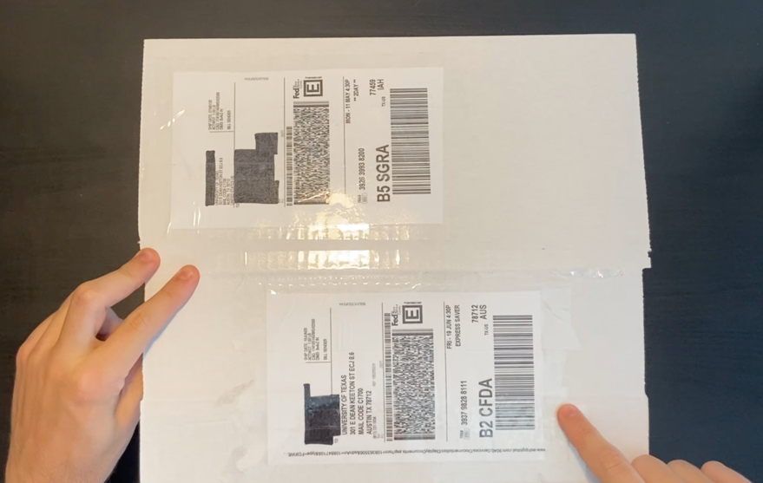

2

1

1. Locate the edge of the tape securing the shipping label 1 to the top of the box and, using your fingernail or something sharp, remove the label – it should come off rather easily.

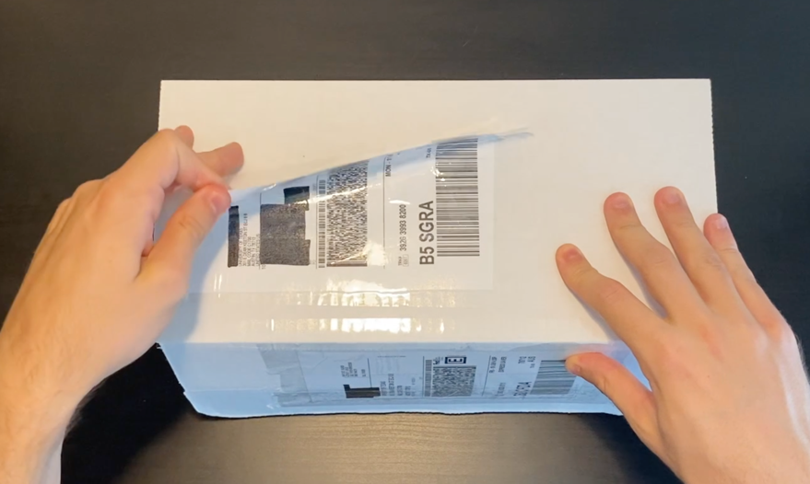

1. Fold the flap to the **OUTSIDE** of the box and use the remaining three blank adhesive shipping labels to tape up the box. **IMPORTANT:** Do not insert the fold-in flap into the box or cover shipping label 2 with the blank adhesive labels. Make sure shipping label 2 is visible on the outside and no writing on shipping label is covered.

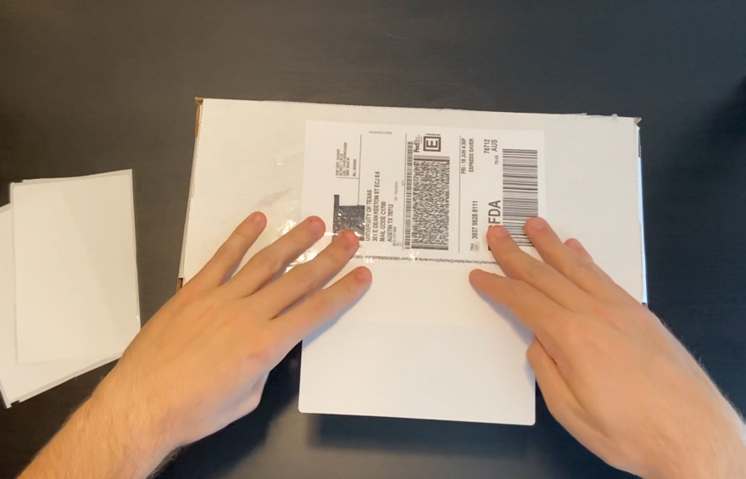

2

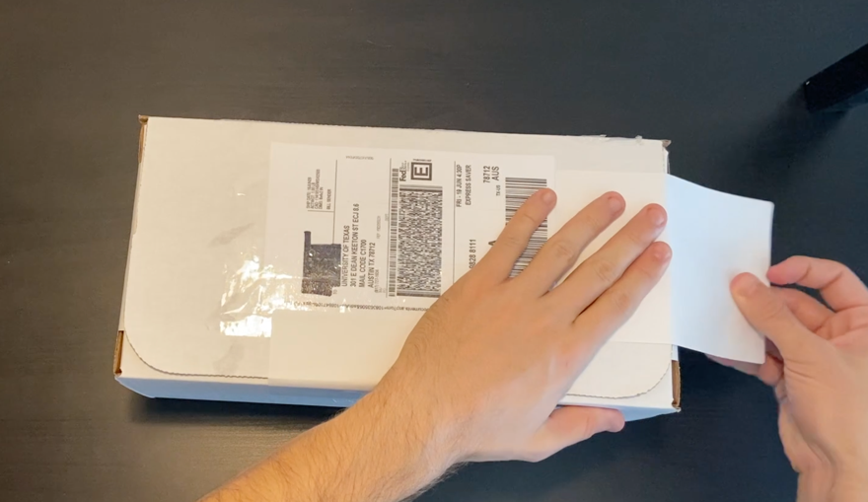

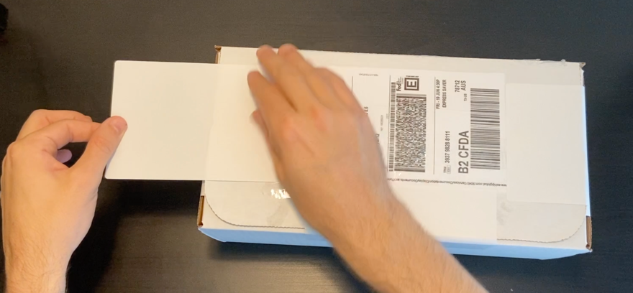

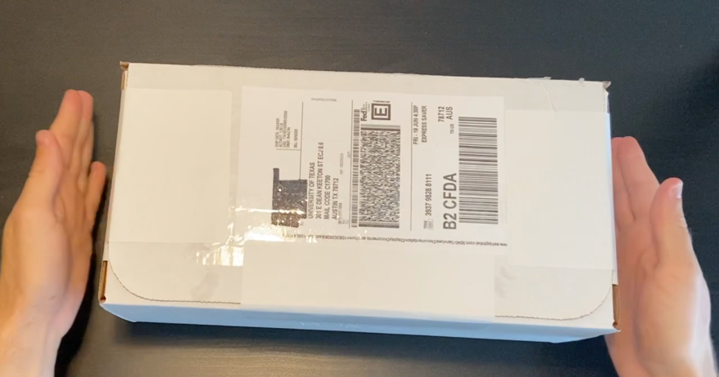

# Mailing the Return Box

We are using FedEx Express to ship the boxes. The pre-paid label on your box is your ticket to shipping, however you will have to locate a FedEx drop box and place the package inside. Please use this website (<https://www.fedex.com/en-us/shipping/dropbox.html>) to locate a drop box closest to you. If there are none near you or cannot access the drop box, let us know at [ut2000study@gmail.com](mailto:ut2000study@gmail.com) and we can help sort things out.

# Troubleshooting

Having an issue? Email us at [ut2000study@gmail.com](mailto:ut2000study@gmail.com) and we will get back to you as soon as possible. Also be sure to check out the [video](https://youtu.be/m_7nJ7iGOYc) if you haven’t already.